- Name: Marian Kostadinov

- Email: mariankostadinov01@outlook.com

- Signature:

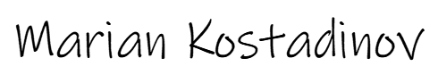

- Payer Name: Ahmed Elkhodary

- Company: Trivergence LLC

- Payer Address:

401 Vista Trail Dr

Lewiseville, TX 75067

- Payer phone number:

+1 571-232-7875

- Payer Signature:



- Date the contract was signed: 2023-01-28

- A description of the goods or services provided:

Project name:

Mobile app development for the form builder with React Native

Content:

Implement new UI of form builder

Add the function which select the theme of form

Work on building IPA

- Details of the price(s) being charged for the goods or services provided:

Hourly rate: $20

Worked time for the project: 120 hours

Price: 20 \* 120 = $2400